OpenCMIS Server Development Guide

Building custom CMIS servers with the
Apache Chemistry OpenCMIS Server Framework

This work is licensed under a Creative Commons Attribution 3.0 Unported License.

Version History:
Version 1.0 November 6, 2013

The most current version of this document can be found at :
https://github.com/cmisdocs/ServerDevelopmentGuide
in the ./docs subdirectory.

Authors:
Jay Brown, ECM Architect, IBM
Florian Müller, ECM Architect, SAP

Table of Contents
Introduction 3
Overview 3
Acknowledgements 3
Prerequisites 3
Goals of the tutorial 4
Tutorial task description 4
Initial setup of your developer environment 4
Getting and building the latest OpenCMIS libraries 5
Initial build of OpenCMIS 5
Building OpenCMIS 6
Getting the project source from GitHub 8
Building the solution from the command line 9
Building and running from Eclipse 11
Importing the project into Eclipse 11
Setting up a Tomcat server target in Eclipse 14
A note about running from Windows 15
Running and debugging from Eclipse 16
A note about startup timeouts 16
Connecting CMIS Workbench to our local server 18
Starting Chemistry Workbench 19
Creating a new server project from scratch 21
A cooks tour of the cmisFileBridge project 22
OpenCMIS Server Framework Interfaces 22
CmisService 23
CmisServiceFactory 24
OpenCMIS Server Framework Operation 24
FileBridgeCmisServiceFactory 25
FileBridgeCmisService 26
FileBridgeRepositoryManager 26
FileBridgeRepository 26
ContentRangeInputStream 26
FileBridgeUserManager 27
FileBridgeUtils 27
FileBridgeTypeManager 27
Tutorial exercises 27
Exercise 1: Filling out the RepositoryInfo structures 28
Exercise 1.1 Setting the CMIS supported version 29
Exercise 1.2 Setting product, version and vendor 29
Exercise 1.3 Setting the root folder ID 29
Exercise 2: Computing CMIS IDs for your objects 30
Spot the design problem 30
Exercise 2.1 Handle null and root when computing IDs 31
Exercise 3: Returning an Object 31
Exercise 3.1 Getting the File or Folder 31
Exercise 3.2 Identify all of the Properties 32
Exercise 3.3 Return the Properties 32
Exercise 3.4 Honoring the Property Filter 33
Exercise 4: getContentStream 33
Exercise 4.1 Offset and Range 34
Exercise 5: Adding logging and tracing to your server 34
Exercise 5.1 Adding slf4j to our project for logging 35
Exercise 5.2 Adding some logging code 37
Exercise 5.3 Observe the logging output 37
Exercise 5.4 Overwriting the web.xml file to enable HTTP tracing 38
Examine the HTTP trace output 40
Exercise 6: Testing your CMIS server 41
Exercise 7: Supporting multiple repositories for your service 44
Miscellany for Developers 46
IBM Content Navigator's CMIS client - minimum requirements 46
Subversion clients for Windows 47
Auto start Chemistry Workbench connected to your server 48
Conclusion 48
Resources 49

Introduction

Overview
In this tutorial you will be introduced to the Apache Chemistry project, its architecture, tools and APIs but from a perspective of a developer that needs to build a custom server. We will be focusing specifically on building our server using Java and even more specifically using the Apache Chemistry OpenCMIS Server Framework.

Acknowledgements
We would like to thank IBM and SAP for supporting the creation of this guide and the corresponding source code.

Prerequisites
- Experience with Java development using Eclipse and Maven.
- It is assumed the reader has a good familiarity with the CMIS specification and its purpose.
  - For a quick tour, the Apache Chemistry site has a “What is CMIS?” page with lots of useful links to get you acquainted here: http://chemistry.apache.org/project/cmis.html.
  - Also the first chapter of “CMIS and Apache Chemistry in Action” is a very good introduction and is available as a free pdf download at Manning's site here: http://www.manning.com/mueller/
  - Finally it is always a good idea to keep a copy of the CMIS specification handy. (see resources section at end of document for links)
- A familiarity with Apache Chemistry CMIS Workbench is helpful but not mandatory. Refer to the 10 minute video introducing this tool if you are not already familiar with it here: http://www.youtube.com/watch?v=akvCDVh03qs . Note that this video refers to a much older version of Chemistry Workbench than is available today but the general concepts have not changed.

Goals of the tutorial
- Understand how to use the OpenCMIS server framework to build CMIS 1.0+1.1 compliant servers.
- Understand the scope of server side Apache Chemistry OpenCMIS and be able to build its dependencies locally.
- Understand the CMIS Workbench tool and become familiar with it by using it throughout this tutorial.
- Understand how enterprise CMIS clients can have varying requirements for the servers they connect to.

Tutorial task description
In this tutorial we will be using OpenCMIS APIs to build a CMIS 1.1 server on top of a local filesystem using the latest version of the Apache Chemistry OpenCMIS Server Framework. We will show all of the aspects of this development from the initial setup of a blank server template using a Maven archetype, through development, deployment and testing of the finished product. The purpose of this exercise is to demonstrate the server framework on top of a simple and universally understood backend (a typical filesystem). Once you understand the steps in this document you should be able to extrapolate this knowledge into what will be required to build a CMIS server on top of whatever server or legacy application that you wish to expose to the world of CMIS clients.

Initial setup of your developer environment
The tutorial assumes you have the following installed:
- Eclipse EE edition “Kepler” (v 4.3.0) or later
  - This is the Java IDE that we will be using for editing / compiling and running our project.
- Apache Maven 3.0.5 or later
  - The command line version of Maven for building our project outside of the Eclipse IDE.
- Svn client, version 1.6.19 or later
  - A subversion client is needed in order to retrieve the project from our source repository. If you don't want to use SVN you can also go directly to the source location and download a zipped bundle of the source code.
- Java JDK version 1.7.0_25 or later
  - Any current JDK should work. Has also been tested with IBM's JDK 6 and above.
- Apache Tomcat v 7.x
  - The servlet container for hosting our server. Tomcat is not required but deploying this server to other JEE containers like WebSphere, JBoss and WebLogic is outside the scope of this tutorial.

All of the these tools we have chosen for this tutorial can be freely obtained and can be installed on Windows, OSX or Linux equally well.

Getting and building the latest OpenCMIS libraries
Although all you need to perform these exercises is the latest version of the OpenCMIS libraries we are going to start off by downloading the source and compiling all of the libraries ourselves. This includes the Apache Chemistry Workbench CMIS client application that we will be using for testing our server. Once you see how easy this is (just a couple of commands) you will be a lot more comfortable doing this if you ever end up in a situation where you need a fix or a feature that is only in the latest snapshot. So lets get started!

Initial build of OpenCMIS
Our first step will be to download the latest version of the source code from the Apache Chemistry SVN repository. Create a directory where you would like the Apache Chemistry source tree to be located. This is not going to be the location of our project, but the build location of the libraries that our project will be using. It can be under the same project directory if you wish but this may be used by other projects later so a shared location may be preferable. When completed it will take about 250 MB of space after your first build is completed.

From a command prompt, cd into your new directory and enter:

svn checkout http://svn.apache.org/repos/asf/chemistry/opencmis/trunk

then press enter to start the checkout operation. This may take a few minutes depending on your connection speed.

Building OpenCMIS
To build the entire tree we need to change directories to the top of the source tree where the top level Maven pom.xml file is located. CD into the ./trunk directory if you are not already there.

Since the build is pretty large, let's increase the max Java heap size for Maven here:

export MAVEN_OPTS='-Xmx1024m -XX:MaxPermSize=512m'

Windows Note: use 'set' in place of 'export' for (and omit the quotes) throughout this document.
Then we will run the build skipping the tests like this:
mvn clean install -Dmaven.test.skip=true

If you have out of memory errors, etc., try running a second time without the clean like this:
mvn install -Dmaven.test.skip=true
This is also a much faster way to build if you are just refreshing after a few small changes.

Also note that adding
mvn clean install -Dmaven.test.skip=true -Dorg.apache.chemistry.opencmis.tck.test=false

will turn off the TCK tests during the build and reduce total build time and memory needed even further.

Output from a successful run will look something like this.

… <lots of build output stuff>
[INFO] ------------------------------------------------------------------------
[INFO] Reactor Summary:
[INFO]
[INFO] Apache Chemistry OpenCMIS ......................... SUCCESS [6.509s]
[INFO] OpenCMIS Commons API .............................. SUCCESS [7.682s]
[INFO] OpenCMIS Commons Implementation ................... SUCCESS [28.164s]
[INFO] OpenCMIS Client API ............................... SUCCESS [0.933s]
[INFO] OpenCMIS Client Bindings Implementation ........... SUCCESS [9.337s]
[INFO] OpenCMIS Client Implementation .................... SUCCESS [4.917s]
[INFO] OpenCMIS Server Support ........................... SUCCESS [19.647s]
[INFO] OpenCMIS Server Implementation .................... SUCCESS [5.766s]
[INFO] OpenCMIS Server Implementation WAR packaging ...... SUCCESS [3.026s]
[INFO] OpenCMIS Test Utilities ........................... SUCCESS [1.323s]
[INFO] OpenCMIS InMemory Server WAR packaging ............ SUCCESS [6.233s]
[INFO] OpenCMIS FileShare Server Implementation .......... SUCCESS [2.180s]
[INFO] OpenCMIS JCR Server Implementation ................ SUCCESS [4.261s]
[INFO] OpenCMIS Server Archetype ......................... SUCCESS [2.366s]
[INFO] OpenCMIS Bridge WAR packaging ..................... SUCCESS [1.783s]
[INFO] OpenCMIS Test Compatibility Kit ................... SUCCESS [2.897s]
[INFO] OpenCMIS Full Integration Tests ................... SUCCESS [27.091s]
[INFO] OpenCMIS Tools .................................... SUCCESS [2.245s]
[INFO] OpenCMIS Browser .................................. SUCCESS [0.320s]
[INFO] OpenCMIS Browser Application ...................... SUCCESS [0.267s]
[INFO] OpenCMIS Workbench ................................ SUCCESS [30.709s]
[INFO] OpenCMIS OSGi Client Wrapper ...................... SUCCESS [4.938s]
[INFO] OpenCMIS OSGi Server Wrapper ...................... SUCCESS [2.569s]
[INFO] OpenCMIS Android Client ........................... SUCCESS [10.049s]
[INFO] OpenCMIS Assemblies Distribution .................. SUCCESS [0.239s]
[INFO] ------------------------------------------------------------------------
[INFO] BUILD SUCCESS
[INFO] ------------------------------------------------------------------------
[INFO] Total time: 3:09.301s
[INFO] Finished at: Wed Aug 28 15:33:03 EDT 2013
[INFO] Final Memory: 134M/347M
[INFO] ------------------------------------------------------------------------
2013-08-28 15:33:04.245:INFO::Shutdown hook executing
2013-08-28 15:33:04.245:INFO::Shutdown hook complete

Getting the project source from GitHub
All of the source code for this project is publicly available on GitHub and is Apache 2 licensed so that you can feel free to copy it, reuse it, sell it or whatever you want. Just remember this code is not supported for production use. (legal disclaimer)

Create a directory to contain the source code tree for the project. For consistency throughout the tutorial let's hypothetically use:

/root/Desktop/dev.tools/project.code

In a terminal window cd to your new project directory and execute the following command to checkout the project source tree.

svn checkout https://github.com/cmisdocs/ServerDevelopmentGuide

After this completes, take a moment to examine the structure of the project before we move on to building it for the first time.

The illustration below shows the directory once it has been extracted or checked out.
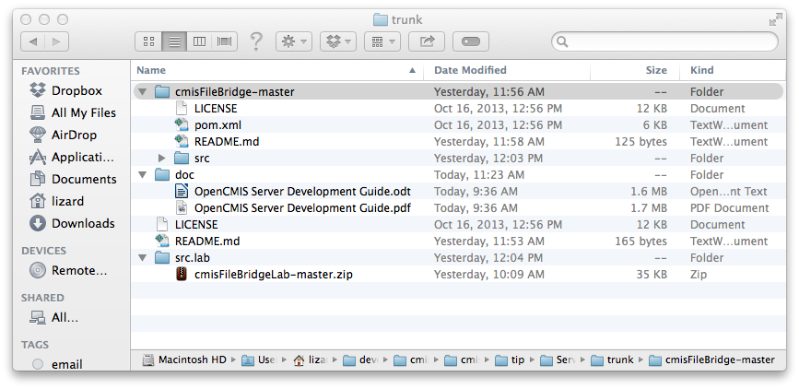
The contents are as follows:
- cmisFileBridge-master: Contains the actual working version of the cmisFileBridge sample CMIS server application from the guide.
- doc: Contains the various renderings of this document (pdf, etc)
- src.lab: Contains a zipped lab version of cmisFileBridge. This version will not compile until the lab exercises are completed by the student. Use of this version of the project is optional.

Building the solution from the command line
Throughout this project we will be using Eclipse to edit, compile, debug and run our project; but before we get to Eclipse it is always good to know how to build the project from the command line. Perhaps you prefer Vi, Emacs, Netbeans or even Notepad. (no judging here) In all these cases we would change to the directory that contains your pom.xml file. In the case of our hypothetical tutorial directory we chose earlier that will be the

/root/Desktop/dev.tools/project.code/cmisFileBridge-master

directory and execute the following command:
(Note this must be executed from the same location as the project pom.xml file)
mvn clean install -Dmaven.test.skip=true

(does that command look familiar?)

After a few seconds, you should see something like this at the tail end of a lot of output.

[INFO] Webapp assembled in [764 msecs]
[INFO] Building war: /root/Desktop/dev.tools/project.code/cmisFileBridge/trunk/target/server-1.0-SNAPSHOT.war
[INFO]
[INFO] --- maven-install-plugin:2.3.1:install (default-install) @ server ---
[INFO] Installing /root/Desktop/dev.tools/project.code/cmisFileBridge/trunk/target/server-1.0-SNAPSHOT.war to /root/.m2/repository/org/example/cmis/server/1.0-SNAPSHOT/server-1.0-SNAPSHOT.war
[INFO] Installing /root/Desktop/dev.tools/project.code/cmisFileBridge/trunk/pom.xml to /root/.m2/repository/org/example/cmis/server/1.0-SNAPSHOT/server-1.0-SNAPSHOT.pom
[INFO] ------------------------------------------------------------------------
[INFO] BUILD SUCCESS
[INFO] ------------------------------------------------------------------------
[INFO] Total time: 15.560s
[INFO] Finished at: Wed Aug 28 18:02:01 EDT 2013
[INFO] Final Memory: 16M/55M
[INFO] ------------------------------------------------------------------------

If you want to deploy this WAR file manually to your own Tomcat (or other container) have a look at the target directory under trunk (shown in illustration below) and you will see the xxx-SNAPSHOT.war file. (shown highlighted)

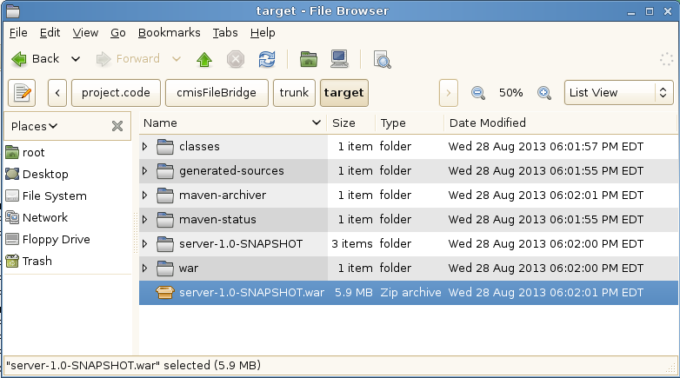
Going forward we will be letting eclipse handle all of our deployments but again its nice to know how to do this manually.

Building and running from Eclipse
Please start your copy of Eclipse for the next part. From here out we will be using absolute paths for locations of files so just compute the difference for your local env based on our initial hypothetical root path.

Importing the project into Eclipse
From the file menu select 'import' and you will see the dialog in the illustration below:

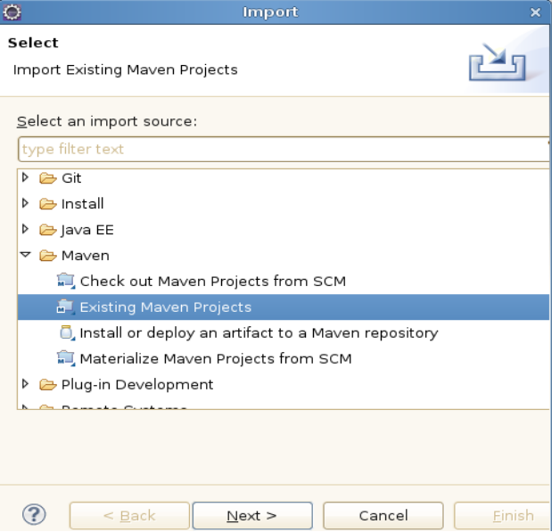

Open up the 'Maven' submenu and select 'Existing Maven Projects' then click 'Next'.
On the next dialog select the 'browse' button to the right of the 'root directory' field then navigate to your trunk directory where the project pom.xml file it located. For the our tutorial environment the location is

/root/Desktop/dev.tools/project.code/cmisFileBridge-master

After selecting the directory, Eclipse will do a bit of processing (reading the pom.xml file) and then display an entry for your project (pre checked) as shown in the illustration below:

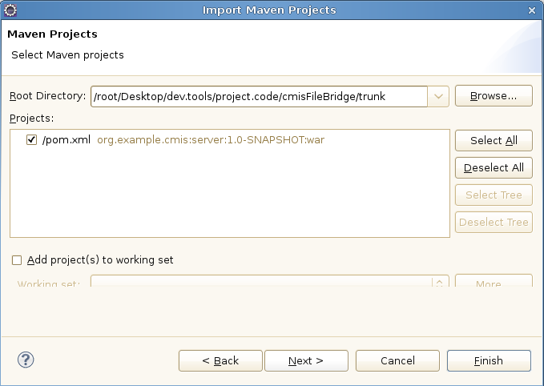

Select 'Finish' to finish the import and go back to your workspace to see the newly imported CMIS server project. The following illustration shows the new project explorer view of the project showing the files in the org.example.cmis.server package.

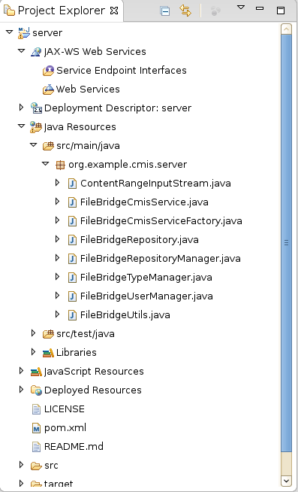

Now that we have the project successfully imported we will setup an embedded Tomcat instance so that Eclipse will have a container target for deployments.

Setting up a Tomcat server target in Eclipse
Download Apache Tomcat 7 from any of the standard mirrors. (e.g. http://tomcat.apache.org/download-70.cgi) and extract the archive to a working location where you want to keep tools for your project. On our hypothetical tutorial image we place the .tar.gz file in the
/root/Desktop/dev.tools/to.install
directory.
Extract this file in place which will create a new
/root/Desktop/dev.tools/to.install/apache-tomcat-7.0.42
directory. Make a note of wherever you place this directory since you will need it in the next step.
Next start your Eclipse again and look at the bottom of your Eclipse workspace at the lower most row of tabs. There you will find a 'Server' tab. Select it and then click on the blue link to create a new server.
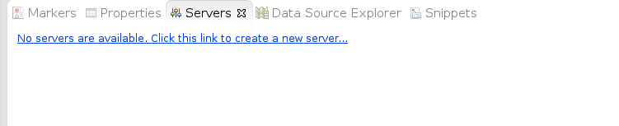Illustration 1: Server tab showing no servers currently configured
Then you will be prompted with the 'Define a new server' dialog. Open up the Apache dropdown and select 'Tomcat v7.0 server' then select the 'Next' button at the bottom.
In the 'Tomcat Installation Directory' field enter in the path where your Apache Tomcat is located (for the tutorial we are using /root/Desktop/dev.tools/to.install/apache-tomcat-7.0.42) then click 'Next'.
On this last dialog (Illustration below) you will select your server app on the left and press the 'Add' button which will move it over into the 'Configured' side like shown in the illustration below:
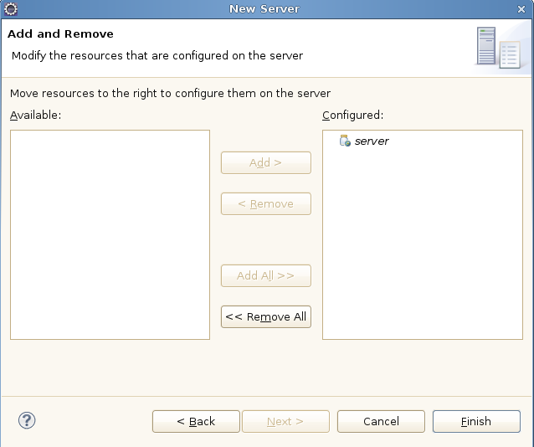Illustration 2: New server dialog showing our server app configured
Press 'Finish' to complete the configuration.

A note about running from Windows
If you are running from Windows you will need to change the repository.properties file (we will talk more about this file later).
Edit the file (see illustration below for location) and change the line
repository.test = /
to point to a more Windows friendly path like
repository.test = c:\\myrootdirectory
and make sure whatever directory you indicate actually exists and has some files and directories already populated.

The relative location of this properties file is shown in the illustration below:
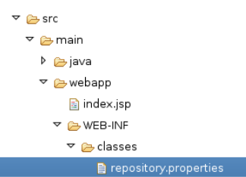

Running and debugging from Eclipse
Now all that is left is to tell Eclipse to run our project. Select your new Tomcat server instance in the Servers tab and press the green 'start' button as shown in the illustration below:
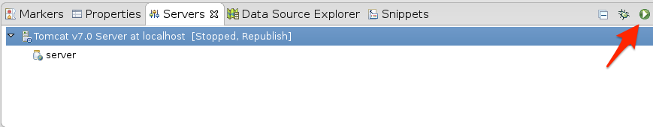
Illustration 3: Server tab with application ready to run

You will know when the server has started when you see an info message in your 'Console' tab showing successful startup like this:
INFO: Server startup in 14322 ms

A note about startup timeouts
If you are running on a slower machine it is possible that the server will not start up within the default timeout window that is defined by Eclipse. If you notice that your server is timing out you can increase the timeout value by double clicking on the server entry in your 'Servers' view. This will open up the Tomcat server properties page (shown in illustration below). On that page you will find a 'Timeouts' section where you can increase the value (from 45 seconds) to whatever is appropriate for your machine (perhaps 90 seconds).
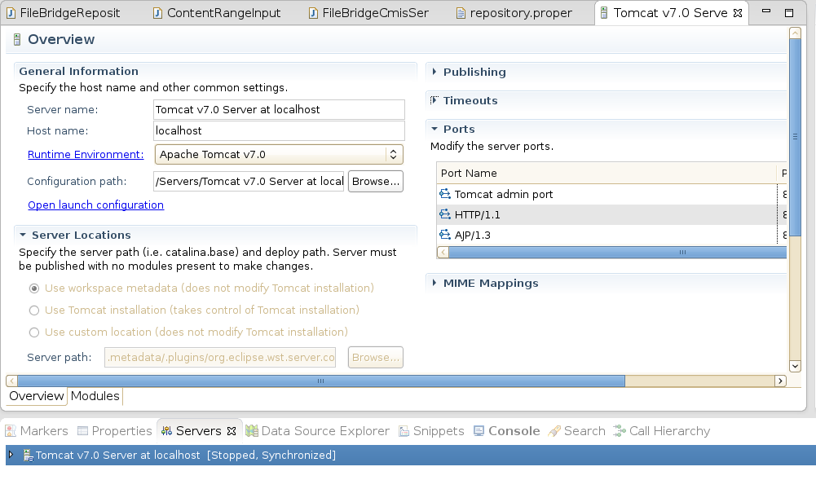

At this point lets bring up firefox to see our new servers landing page and make sure it really did startup. Go to http://localhost:8080/server/ and you should see a page like the following illustration.
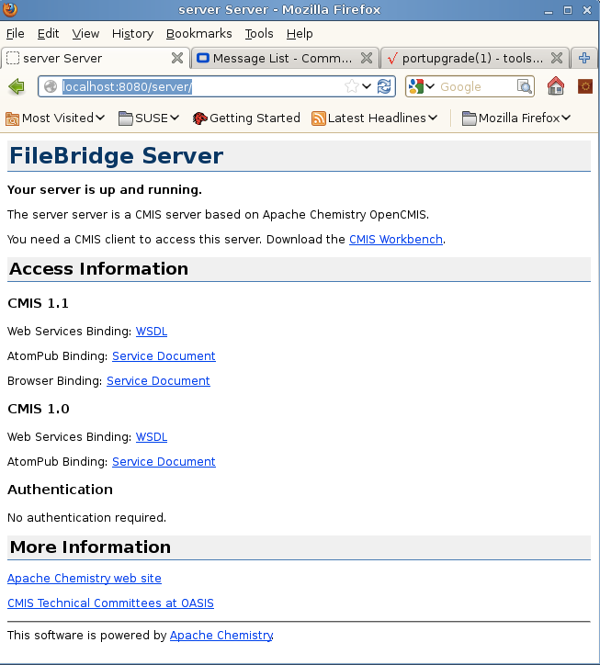Illustration 4: Firefox showing the landing page for the FileBridge CMIS server

Now we are ready to connect Workbench and poke around to see what this little bit of code can really do.

Connecting CMIS Workbench to our local server
Ordinarily to run CMIS Workbench you would just download the latest binary from the download page but since we have just did a local build of the entire OpenCMIS tree lets go ahead and use the one that we have just built instead.

Go back to your chemistry.trunk directory and navigate down into
/trunk/chemistry-opencmis-workbench/chemistry-opencmis-workbench/target

Here you will grab the file that ends with -SNAPSHOT-full.zip as shown in the illustration below:

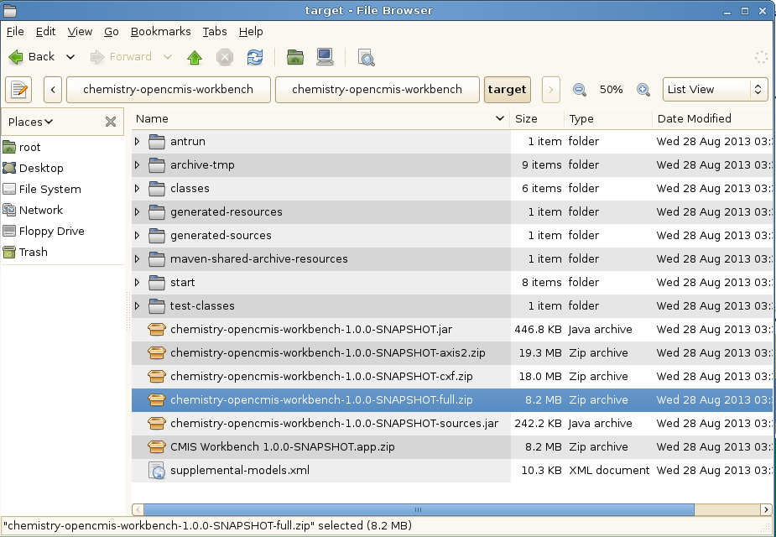Illustration 5: Workbench target files after OpenCMIS build
Copy the zip file up to a shared dev.tools directory (in our tutorial we will use desktop/dev.tools) There create a new sub-directory named Workbench. Once there uncompress the file.

Starting Chemistry Workbench
Running the workbench is now just a matter of running workbench.sh (if on Linux or Mac) or workbench.bat (if Windows). After running this command you will see the following dialog (illustration below) asking you for connection information to your server.
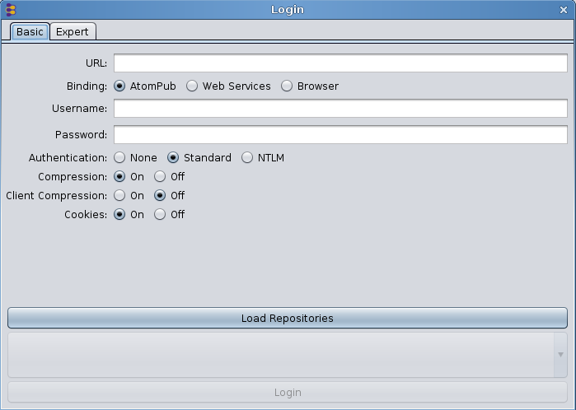
Since our server is still running all we need to do is enter in the connection info and we will be off and running.

Select the 'Expert' tab and paste in the following info:

org.apache.chemistry.opencmis.binding.spi.type=browser
org.apache.chemistry.opencmis.binding.browser.url=http://localhost:8080/server/browser
org.apache.chemistry.opencmis.user=test
org.apache.chemistry.opencmis.password=test
org.apache.chemistry.opencmis.binding.compression=true
org.apache.chemistry.opencmis.binding.cookies=true

Note: You don't have to use the expert tab. You can also separately enter in the URL, user and password values then click on the 'Browser' radio button. Same result. Its just less steps to use the expert page. (e.g. a single paste)

Select the 'load repositories' button then click on 'login' and you should almost immediately see the root directory displayed like the illustration below:

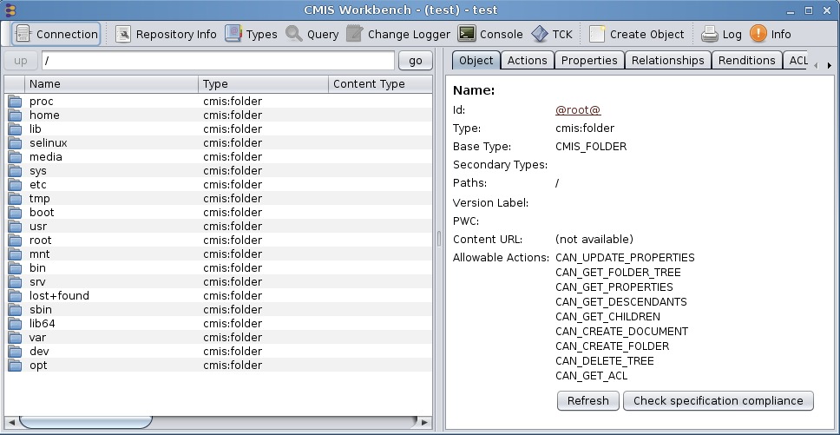Illustration 6: First screen you see in Workbench after login and selecting a repository

Creating a new server project from scratch
Now that you have seen how to build and run the solution lets get down to how to build a project like this from scratch. The text below shows the command line options to pass to Maven (mvn) to generate our server archetype. This is the command that we used to generate FileBridge. If you want to see this in action create a temp directory and give it a shot now.

mvn archetype:generate \
-DgroupId=org.example.cmis \
-DartifactId=server \
-Dversion=1.0-SNAPSHOT \
-Dpackage=org.example.cmis.server \
-DprojectPrefix=FileBridge \
-DarchetypeGroupId=org.apache.chemistry.opencmis \
-DarchetypeArtifactId=chemistry-opencmis-server-archetype \
-DarchetypeVersion=1.0.0-SNAPSHOT \
-DinteractiveMode=false

Note: This archetype generation step can also be done GUI-style,with the latest version of Eclipse (with Maven integration) We are leaving that out of the tutorial to save space but feel free to use that instead (as an extra exercise) if you prefer.

Some highlights to note here concerning these values :

- groupId, artifactId, and version: These are the Maven 'coordinates' for the code you are generating. (see: http://maven.apache.org/pom.html#Maven_Coordinates for more info on these)
- package: The Java package for the code.
- ProjectPrefix: Prefix for all the classes that will be generated. For example, the prefix FileBridge generates the classes FileBridgeCmisService and FileBridgeCmisServiceFactory.
- archetypeGroupId, archetypeArtifactId, and archetypeVersion: OpenCMIS archetype and OpenCMIS version that should be used. The archetype OpenCMIS 1.0 may be available by the time you read this. This version also defines the runtime OpenCMIS Server Framework version.
- InteractiveMode: If false, Maven won’t prompt you for confirmations during the generation process.

A cooks tour of the cmisFileBridge project
Before we explain the different components and classes of the FileBridge, you have to understand first how the OpenCMIS Server Framework works at a more generic level. The following material is a condensed version of the material provided in the initial lecture we did on this subject at IBM's IOD conference in 2013 prior to the lab (based on this tutorial). It is provided as a convenience for the folks not taking the lab in person. For a more complete explanation of these issues please refer to chapter 14 in the 'CMIS and Apache Chemistry in Action' book (see References). As we move through and discuss the different key classes and interfaces, take a moment to examine the corresponding code in your solution project.

OpenCMIS Server Framework Interfaces
The OpenCMIS Server Framework is a web application that runs on top of a servlet engine such as Tomcat, Jetty, or an application server like WebSphere (Shown in the illustration below). It handles all CMIS requests and responses and does all the XML and JSON processing. It also hides the details of CMIS bindings from the developer by turning incoming data into Java objects and outgoing data from Java objects into XML or JSON.

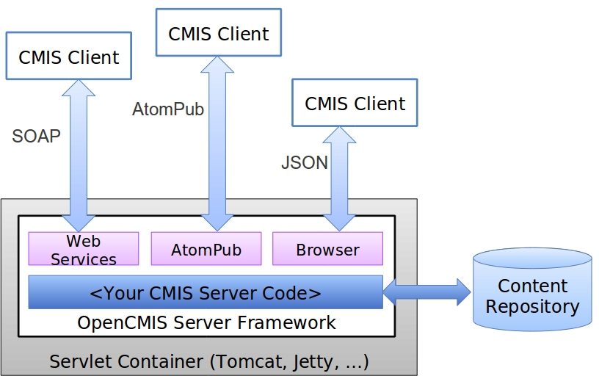

To connect the server framework to the content repository, you have to implement two Java interfaces: CmisService and CmisServiceFactory.

CmisService
The CmisService interface aggregates all CMIS 1.0 and CMIS 1.1 operations plus a few additional methods. There are over 50 methods in total that can be implemented. The methods and method parameters are named after the operations that are described in the “Services” section of the CMIS specification. The implementation of the CmisService interface is supposed to behave as defined in the specification. That includes throwing the exceptions documented there.
Implementing all these methods sounds tedious doesn't it? Luckily, OpenCMIS provides the abstract class AbstractCmisService, which implements the CmisService interface and provides convenience implementations for most methods. It reduces the number of required methods to just six. Providing implementations for these six methods doesn’t make the CMIS connector specification compliant, but it is sufficient for many CMIS clients (like the CMIS Workbench) to navigate through the folder structure. It’s recommended to extend this class instead of implementing the interface directly. You’ll see an example later when we discuss the FileBridgeCmisService class.

CmisServiceFactory
The main task of an implementation of the CmisServiceFactory interface is to provide CmisService objects. Whenever the server framework receives a request, it asks the CmisServiceFactory for a CmisService object, which is then used to process the request. There is only one CmisServiceFactory object per web application. This object also manages the initialization and shut down of the CMIS connector and provides some configuration values for the server framework. The CmisServiceFactory object must be thread-safe but the CmisService objects it produces don’t need to be because they are only used for one request.
OpenCMIS provides the abstract class AbstractServiceFactory, which should be used to build a service factory because it sets some sensible default values among other details. The FileBridgeCmisServiceFactory class, which we will walk through later, also extends the AbstractServiceFactory class.

Next, let’s see how the server framework uses these objects.

OpenCMIS Server Framework Operation
The server framework web application consists of five servlets and two context listeners (shown in illustration below). It provides two CMIS 1.0 endpoints (for the AtomPub and the Web Services binding) and three CMIS 1.1 endpoints (for the AtomPub, the Web Services, and the Browser binding). Each endpoint can be disabled if necessary by editing the web.xml of the web application.
One of the context listeners sets up the CmisServiceFactory object and calls it’s init() method when the web application starts up.

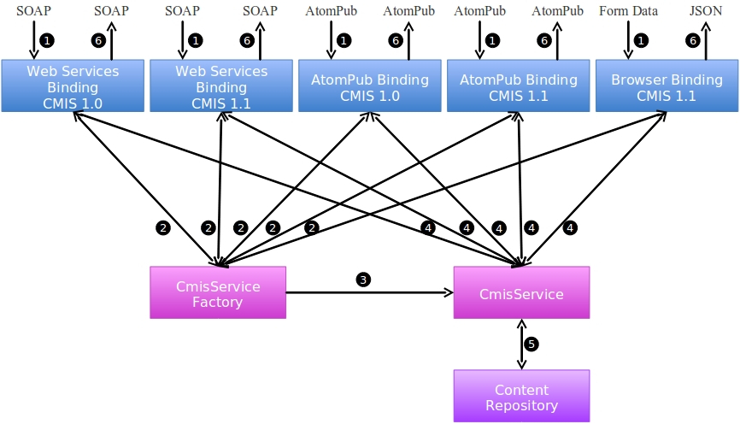

Incoming CMIS requests are processed by the servlets. The requests are parsed, checked for syntactically correctness, and the data is converted into Java objects. The framework then requests a CmisService object from CmisServiceFactory and calls the suitable method with the received data. The data returned by the method is converted into XML or JSON and sent back to the client.

Now you should have a rough understanding how the server framework works.
Next lets look into the FileBridge implementation – class by class.

FileBridgeCmisServiceFactory
As you might figure out from the name, the FileBridgeCmisServiceFactory is the service factory class for the FileBridgeService. Its init() method gets the repository configuration and sets up all necessary objects. The init method receives a map of configuration parameters. This map represents the content of the repository.properties file, which resides in the classpath. The repository.properties file is used by the server framework to identify the service factory class and must at least contain an entry with the key “class” and the fully qualified classname of the service factory as the value. The repository.properties file can also contain any other configuration. In case of the FileBridge, we use it to configure the repositories, their root paths on disc, and the logins. The readConfiguration method iterates through the map, collects all the repository and login details and stores them in the repository manager (FileBridgeRepositoryManager) and the user manager (FileBridgeUserManager).

It’s main task, though, is to serve FileBridgeCmisService objects. The framework calls the getService method whenever it needs one. The framework provides a CallContext object, which contains all kinds of details about the incoming call. That includes the user name and the password that the client sent. Before the FileBridgeCmisServiceFactory returns a FileBridgeCmisService object, it hands the CallContext object over to the user manager (FileBridgeUserManager) to authenticate the user. If the authentication fails, it throws a CmisPermissionDeniedException.

Now it’s time to serve a FileBridgeCmisService object. There are multiple ways to manage those objects. The easiest, but most inefficient way would be to create a new object every time. Here, we decided to use a ThreadLocal. Over time each thread will have it’s own object that is reused when a subsequent request hits that thread.
FileBridgeCmisService objects are very lightweight and are only proxies for repository objects (FileBridgeRepository), which we’ll discuss in a moment. For heavyweight CmisService objects or CmisService objects that are expensive to create, a pool of objects might be a better option.

FileBridgeCmisServiceFactory does not return a FileBridgeCmisService object directly, but FileBridgeCmisService objects that are wrapped by a CmisServiceWrapper object. The CmisServiceWrapper is an optional class provided by OpenCMIS. The wrapper checks a request for specification conformance before the request is forwarded to the wrapped service object. If a client sends an invalid request, for example if it didn’t provide a mandatory parameter, the wrapper throws the appropriate exception without bothering the service object. The wrapper also sets parameter values for parameters the client didn’t provide but the specification defines default values for. Using this wrapper is recommended because it helps building more robust CMIS servers, however it is not required.

Once the FileBridgeCmisService object has been created or retrieved, the CallContext object is handed over to the object, and the service factory returns the object to the server framework.

FileBridgeCmisService
The FileBridgeCmisService class implements the CmisService interface and therefore has to provide over 50 method implementations. By extending the AbstractCmisService class, we can focus here on just the methods that we want to (and can) implement.
The FileBridgeCmisService only contains a tiny amount of logic since its task is merely to forward the call to the appropriate repository instance.

FileBridgeRepositoryManager
The repository manager maps repository IDs to FileBridgeRepository object, which in turn contains the repository logic. The repository manager is set up when the FileBridgeCmisServiceFactory starts up and is used by the FileBridgeCmisService to find the right FileBridgeRepository object.

FileBridgeRepository
The FileBridgeRepository class contains the main logic of our CMIS server. There is one instance per repository at runtime. It has to be thread-safe because multiple threads could access the same repository at the same time.
The FileBridgeRepository class maps CMIS operations to file system operations. Most of the code is straightforward. Creating a document or folder maps to creating a file or directory on the file system. The CMIS operations getObject and getContentStream provide metadata and content respectively of a file (or folder). The getChildren and getDescendants operations return a list or tree of children of a directory. And so on.
We skip the details here because the implementation of this class is the main topic of this tutorial's exercises.

ContentRangeInputStream
The getContentStream operation allows a client to request an excerpt from a document content by proving an offset and a length. This class is a simple wrapper around a Java InputStream that takes the offset and length into account. The FileBridgeRepository uses it when getContentStream is called and the client has requested a content excerpt.

FileBridgeUserManager
The FileBridgeUserManager manages the logins and passwords. It is kept very simple and acts a placeholder for a real user management system that you would be connecting to. In FileBridge, logins are necessary to demonstrate the Allowable Actions and ACLs features. The FileBridgeRepository distinguishes between read-only and read-write users, which affects the Allowable Actions and ACLs.

FileBridgeUtils
This class provides a set of static helper methods. Most of them deal with extracting values from a set of properties and are mainly used in FileBridgeRepository.

FileBridgeTypeManager
This class manages the CMIS type system. All repositories share the same type system in this implementation and therefore there is just one instance of this class at runtime.
The type manager is as simple as it can be. It only manages the two base types for documents and folders. It provides access methods to these type definitions that are similar to the CMIS operations.
This class makes use of the TypeDefinitionFactory, which is an OpenCMIS helper class that provides methods to create and transform type and property definitions in a CMIS compliant way. It should work for all servers with a straight forward type hierarchy and provides spec conforming base type definitions. This is helpful to developers starting with CMIS setting up a spec compliant type system quickly which can otherwise be somewhat tedious.
Note: In your own custom repository you may need to have a separate set of type definitions per repository.

Tutorial exercises
For all of the exercises that follow, we have setup a special version of the fileBridge project. The only differences between this code and the working solution at is small chunks of code that correspond to the exercises below have been removed. You will find this 'lab' version of the project in a zip archive in the /src.lab directory under the main project (a peer of the doc) directory.

If you prefer to stay with the one working project we have already setup and walk through the exercises without actually writing the code, that is fine too. The most important part of these activities is actually navigating around to these different places and seeing how the project all fits together.

If you want to work through these exercises with the lab version code then please setup a second workspace following the directions outlined in 'Getting the project source from GitHub' but using the contents of the zipped archive.

Exercise 1: Filling out the RepositoryInfo structures
For our first exercise we will be doing something that should be one of the first things you will code up when you create your own server. That is populating the RepositoryInfo structure and now that we have CMIS 1.1 clients to accommodate (in addition to CMIS 1.0) there are a few finer points that you will need to be aware of.
Navigate to the FileBridgeRepository class in your lab copy of the project (rather than the solution). Then proceed down to the

private RepositoryInfo createRepositoryInfo(CmisVersion cmisVersion)

method.

Lets take a moment to look at the context of how this is first called. A breakpoint set at the top of this method shows the following when we startup the server.

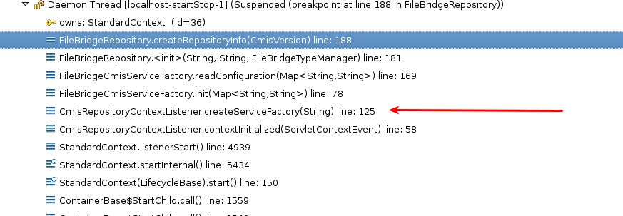

The red arrow in the illustration above shows the call to the createServiceFactory. There the init() method is called, which after setting up its 3 manager classes, calls readConfiguration() passing it the parameters that were read from the repository.properties file.
At the tail end of readConfiguration(), the constructor for FileBridgeRepository is called which calls createRepositoryInfo two times. Once with Version.CMIS_1_0 passed in and once with CmisVersion.CMIS_1_1. You may wonder why do we need two of these?
Recall during the cooks tour in the 'OpenCMIS Server Framework Operation' section, we talked about how there are 5 servlets setup by the framework. These are divided into two groups, 2 of the endpoints for CMIS 1.0 and 3 for 1.1 We are pre populating a unique repository info versioned for each of these so if a CMIS 1.0 client comes in on either of the two 1.0 bindings they will get a CMIS 1.0 compliant repository info structure. Likewise for a CMIS 1.1 client on any of the three CMIS 1.1 bindings.

The structures are the same except for the code that is contained in the block starting with this test:

if (cmisVersion != CmisVersion.CMIS_1_0) {

Please have a look at that code now. You will see these are mostly settings having to do with the new CMIS 1.1 type mutability features.
Armed with this we now should have a better idea what to do for the
repositoryInfo.setCmisVersionSupported(...)
method. All we need to pass in here is the .value() of the cmisVersion object that was passed to us for this method.

Exercise 1.1 Setting the CMIS supported version
Fill in the code that sets the CmisVersionSupported now. The line is marked with this <exercise 1.1>. Remember this must work for both 1.0 and 1.1 clients.

Exercise 1.2 Setting product, version and vendor
Fill in the code that sets the product name, product version and vendor name. The lines are marked with <exercise 1.2>. These values can be anything you want since they are descriptive aspects of the repository info.

Exercise 1.3 Setting the root folder ID
Fill in the code that sets the root folder ID. The line is marked with <exercise 1.3>. To a client this value is an opaque string so you can make this any unique value (unique for this repository) that you wish. In the case of the fileBridge we have created a static string:

private static final String ROOT_ID = "@root@";

Note that you are free to use whatever makes sense in your repository here. It may be a guid that the underlying repository uses to identify the root folder, or it can be a special static value. It all depends on your implementation.

Choosing an ID for your root object is a nice stepping off point to the bigger subject of choosing IDs for all your objects which we will cover in the next exercise.

Exercise 2: Computing CMIS IDs for your objects
Since CMIS IDs are completely opaque to all CMIS clients, often when you build a server you have lots of choices concerning how you should map your internal objects to your external CMIS IDs. A couple of points to remember :

- All IDs expressed to clients MUST be unique per repository.
- There must be a strict 1:1, bi-directional ** mapping between your external IDs and your internal objects. Any ambiguity even for extreme edge cases is going to cause you pain later.
  - ** So for example you could not use a one way hash value. (not bi directional and may have collisions)
- The format of your IDs should be compatible with the CMIS transports XML, JSON and the associated URLs so stay clear of special characters like < >/ \ $ ? * &% etc.

With these in mind how would you go about mapping all filesystem objects to a set of unique IDs? You could use a file's iNode number as its ID. That would certainly be unique and URL friendly but it would limit us to only Unix / Linux filesystems, so lets skip that one.
We could use the fully qualified path (from the root) of the object. That would be unique for sure, but then we have the problem of all of those non URL friendly characters like spaces and '/'s not to mention all of the non-Latin characters that could be in filenames. So what we have done in this sample is base64 encode the path to get the ID and unencode to get the path. This produces IDs that are URL friendly and guaranteed to be 1:1 and bi directional. E.g. /home/test → 'aG9tZS90ZXN0' and then back again.

A note about Base 64 encoding / decoding: OpenCMIS comes with a handy Base64 class (package org.apache.chemistry.opencmis.commons.impl) Take note of it! This class not only implements base64 in the most efficient manner possible but it also supports base64 encoded streams which you will have to deal with here on the server side.

Spot the design problem
It turns out that there is an edge case where the model we have used for FileBridge for mapping ID's to objects violates the specification. Can you guess where that is?
Hint: A CMIS object's ID must not change even if its name changes.

Exercise 2.1 Handle null and root when computing IDs
In this example we are going to be spending all our time in one small method, that being

private String fileToId(File file)

in FileBridgeRepository. This is the one place that gets called when the repository need to obtain a CMIS ID for a given file. Please go there now and have a look at the code in your lab version of the project.
First we need to handle the case marked by <exercise 2.1>.
Here we must do something reasonable if we get passed a null file. In this case we will throw an unchecked exception like:
throw new IllegalArgumentException("Hey now, that's just not right!");

The next case we need to handle here is the case of the root folder ID. Go to the code marked as <exercise 2.2> and substitute in the constant that we talked about in exercise 1.3.

Exercise 3: Returning an Object
Almost all CMIS read operations return object data. The operations getObject and getObjectByPath, for example, return the data of a single object. The same structure is used by list of objects operations like getChildren, getObjectParents, getCheckedOutDocs, getObjectRelationships, and getAllVersions. The operations getDescendants and getFolderTree return a tree of the same object data structure.
In this exercise we assemble such a data structure. The metadata of an object consists of the object properties, Allowable Actions, ACLs, policies, relations, renditions, and so on. We are focusing on the properties for this exercise.
Navigate to the FileBridgeRepository class and find the compileObjectData method. It returns an ObjectData object, which the OpenCMIS server framework needs to compose a response for the client. If you look through the code, you see that this method is used in many places.
The method compileObjectData calls the method compileProperties, which you will implement in the following exercises.

Exercise 3.1 Getting the File or Folder
Find the first marker for <exercise 3.1> and navigate there. Before you return something useful later in the method we need to sure that file or folder exists. If it doesn’t, we need to throw the right CMIS exception.

Hint: Check the CMIS specification and the OpenCMIS JavaDoc (URL's for both in Resources section) for exception definitions. Make those additions now.

Also to note:
If the file or folder exists, we need to identify if it is a file or folder. (nothing to change for this one just be aware what is happening) We need to know this because both types have a slightly different set of properties.

Exercise 3.2 Identify all of the Properties
This exercise will be a research exercise. Consult the CMIS specification for all the document and folder properties. There are quite a few standard properties that have to be returned. Also see the 'CMIS Cheatsheet' in the Resources section for a complete condensed list of the version 1.0 properties.
The properties are of different data types. OpenCMIS provides an implementation class for each CMIS data type named Property<type>Impl. Find them in the OpenCMIS JavaDoc (references section).
For each property mentioned in the specification we must create a Property object with a suitable value. Some values are just constants. For example, the file system doesn’t support versioning. So, the versioning related properties could be hard coded. Other values can be derived from the Java File object such as the name or last modification date.

Hints:
- The class PropertyIds has constants for the property IDs and indicates when which property has been introduced. Make sure that you don’t return CMIS 1.1 properties to a CMIS 1.0 client.
- Documents and folders share a set of base properties but also have type specific properties. Make sure that you take this into account.
- Make sure you treat the root folder correctly. The root folder is unique in that it has no parent folder.
- OpenCMIS provides the helper class MimeTypes that guesses the MIME type of a file.
- You can decide how you want to handle empty files. You can return them as documents without content (and no length and no MIME type) or as an empty document (with length 0 and a MIME type).

Exercise 3.3 Return the Properties
The compileProperties method is supposed to return an object that implements the Properties interface. OpenCMIS provides a simple implementation class called PropertiesImpl. Create an instance of this class and add the Property objects that you have created in the previous exercise. (<exercise 3.2.1>)

Now compute the ID for the object (<exercise 3.2.2>) and add it as a property using our addProperty<type> method (<exercise 3.2.3>). Note that the addProperty<type>() methods are part of FileBridge not OpenCMIS, more on that in the next part. Have a look at some of the other completed property types for examples on how to handle the ID.

Exercise 3.4 Honoring the Property Filter
This exercise will also be a research exercise.
As you already know, clients may provide a property filter when requesting objects.
If you were to look up the property filter description in the CMIS specification you would find they are quite simple. They consist of a comma delimited list of property definition query names. (Go ahead and have a look just to get more familiar with the spec layout)

Our code that added all of the properties used the constant values to identify each property we were adding. (e.g. PropertyIds.BASE_TYPE_ID) So we must be able to convert between those property IDs and the query names used in filters. To understand how this is done, have a look at one of the addProperty<type>() methods to see how it calls checkAddProperty() to see if the property should be added to the response. Next look at the checkAddProperty() method to see how this is implemented. Pay special attention here to how the TypeManager is used to convert from the typeId to the Query name so that it can be compared to the filter.

Exercise 4: getContentStream
Now that we have gotten this far things are going to start looking pretty simple. For this exercise we are going to finish off the implementation of getContentStream; and in doing see some details on how to handle Offset + Range even if your underlying repository does not support them. The illustration below shows what the top of the stack will look like after a call to getContentStream (breakpoint set in FileBridgeRepository.getContentStream())

Exercise 4.1 Offset and Range
Jump over to the

public ContentStream getContentStream

method in the FileBridgeRepository class. Most of the work is done in this line

stream = new BufferedInputStream(new FileInputStream(file), 4 * 1024);

where we initialize a BufferedInputStream with the stream from our local file. What we want to talk about here though is what to do with Offset and Range if they are present.

Look for the exercise token <exercise 4.1> and you will see the block of code we need to fix. Here we have a non null value for offset or length. Jump over to the constructor for the ContentRangeInputStream class to see how we have worked around the filesystem's inability to do this directly. Once you have it understood fill in the three parameters for the constructor (stream, offset, length)and we will be ready for the next exercise.

Exercise 5: Adding logging and tracing to your server
Logging is not in the scope of the OpenCMIS server framework so you may whatever technology or library you prefer for this purpose. Note however that the framework uses SLF4J (http://www.slf4j.org/) for logging internally. So if you want framework log messages in your log files, you may configure SLF4J to use your same logging backend.
In this exercise we are going to show you how to do just that.

Unlike the solution project, the lab version of your project represents a generically generated project from Maven. In order to add logging we are going to have to modify that project in the following ways:
  - Modify the pom.xml to include whatever dependencies we need for our logging framework of choice.
  - Add a log4j.properties file.

In order to add tracing we will be adding a new src/main/webapp/WEB-INF/web.xml file to define our http trace logging filter. Note that http tracing and logging are not related or dependent on each other. You can use one or the other, both or neither. To emphasize this we are separating them into different sections of this exercise.

Exercise 5.1 Adding slf4j to our project for logging
In our sample FileBridge server we have decided to use slf4j as our abstraction logging layer for our code and at deployment time we will be configuring log4j as our logging implementation. To make this change in our project we will modify the project's pom.xml as follows: (right before the closing </dependencies>)

<!-- enables OpenCMIS frame logging to log4j -->
<dependency>
<groupId>org.slf4j</groupId>
<artifactId>slf4j-log4j12</artifactId>
<version>1.7.5</version>
</dependency>

Next we are going to add in the required log4j.properties file.
Locate the log4j.properties file in your solution project's directory and copy it to the corresponding location in your working directory.

/src/main/resources

Now lets do a maven update
(right click on the server project) / maven / update project
just to make sure everything is updated and refreshed.
At this point we will be ready to add some logging code in the next exercise.

For more information about how slf4j can dynamically plug in logging frameworks at deployment time please consult the documentation at http://www.slf4j.org/.
After changing the pom don't forget to do a
(right click on the server project) / maven / update project
to have Maven make all of the necessary changes to your Eclipse project. After selecting this option you will see the dialog in the illustration below:
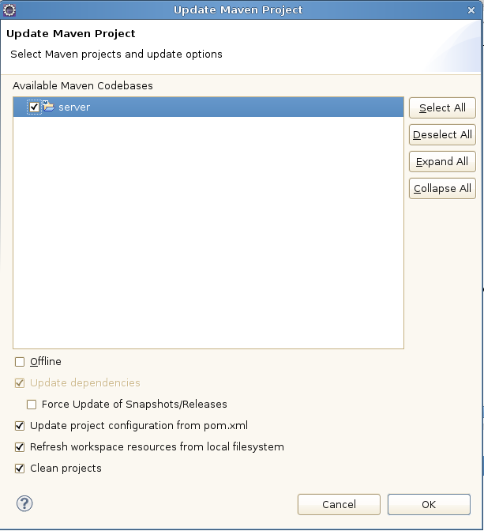

Select 'OK' to continue. After Maven has finished processing you can check the libraries view of your project (server / libraries / maven dependencies) and you will now see the project has the various log4j and slf4j jars associated. (verify this now)

Exercise 5.2 Adding some logging code
Now that all of the dependencies are setup we are going to add a log entry for every time the framework calls the getRepositoryInfos() method on our service.

In FileBridgeCmisService please add the following imports:

import org.slf4j.Logger;
import org.slf4j.LoggerFactory;
Then at the top of the class anywhere between

public class FileBridgeCmisService extends AbstractCmisService {

and the first method definition we will add

private static final Logger logger = LoggerFactory.getLogger(FileBridgeCmisService.class);

then on the first line of getRepositoryInfos we will add the logger (info) line:

logger.info("entering call to FileBridgeCmisService.getReposotiryInfos");

That's all there it to it! We are ready to see it run.

Exercise 5.3 Observe the logging output
Run your server and login with Chemistry Workbench as usual. At this point you should see some output in your Eclipse console window like this:

2013-09-13 19:15:55,728 INFO [http-bio-8080-exec-3] org.example.cmis.server.FileBridgeCmisService: entering call to FileBridgeCmisService.getReposotiryInfos

At this point if you wish to see how this all works in a normal Tomcat container you may want to build from the command line to produce a war file in the /target directory.
Recall how we did this earlier in the lab by running

mvn clean install -Dmaven.test.skip=true

at the top of our project directory (where the pom.xml is located).
Rename the war file (to whatever you wish, e.g. filebridge.war) and deploy to Tomcat as usual. After running again you should see your logging output in the catalina.out file.

Armed with the knowledge of how to add logging, we should be ready to start running some unit tests in the next exercise.

Exercise 5.4 Overwriting the web.xml file to enable HTTP tracing
In this exercise we are going to enable the org.apache.chemistry.opencmis.server.support.filter.LoggingFilter
HTTP tracing filter. In order to do so we will have to make some changes to the web.xml for the servlet.
Note: A generic OpenCMIS server gets its web.xml file from the framework so it will not normally appear in your Eclipse project. But since we need to make changes to it we are going to add one and in the process override the default framework version.

Go to your solution project's src/main/webapp/WEB-INF/ directory and copy the web.xml file from there into the corresponding directory in your lab version of the project. Once it is in place, uncomment out the following xml:

<filter>
<filter-name>LoggingFilter</filter-name>
<filter-class>org.apache.chemistry.opencmis.server.support.filter.LoggingFilter</filter-class>
<init-param>
<param-name>LogDir</param-name>
<param-value>/home</param-value>
</init-param>
<init-param>
<param-name>PrettyPrint</param-name>
<param-value>true</param-value>
</init-param>
<init-param>
<param-name>LogHeader</param-name>
<param-value>true</param-value>
</init-param>
<init-param>
<param-name>Indent</param-name>
<param-value>4</param-value>
</init-param>
</filter>

<filter-mapping>
<filter-name>LoggingFilter</filter-name>
<servlet-name>cmisatom10</servlet-name>
</filter-mapping>
<filter-mapping>
<filter-name>LoggingFilter</filter-name>
<servlet-name>cmisatom11</servlet-name>
</filter-mapping>
<filter-mapping>
<filter-name>LoggingFilter</filter-name>
<servlet-name>cmisws10</servlet-name>
</filter-mapping>
<filter-mapping>
<filter-name>LoggingFilter</filter-name>
<servlet-name>cmisws11</servlet-name>
</filter-mapping>
<filter-mapping>
<filter-name>LoggingFilter</filter-name>
<servlet-name>cmisbrowser</servlet-name>
</filter-mapping>

Note the value of LogDir must be set to a valid directory. For the tutorial image we are using /home. So don't forget to set this value after you uncomment the xml. If you don't the output will go to your temp directory. e.g. /tmp.

Note about performance and tracing:
Use this tracing filter with care! It can generate a huge amount of files (as you will see) and will slow down performance significantly.

The screen shot in the illustration below is of the home directory after a Workbench login has taken place. As you can see there are a total of 8 round trips made in the process of getting the service document, retrieving the type definitions, getting the root folder children, etc.

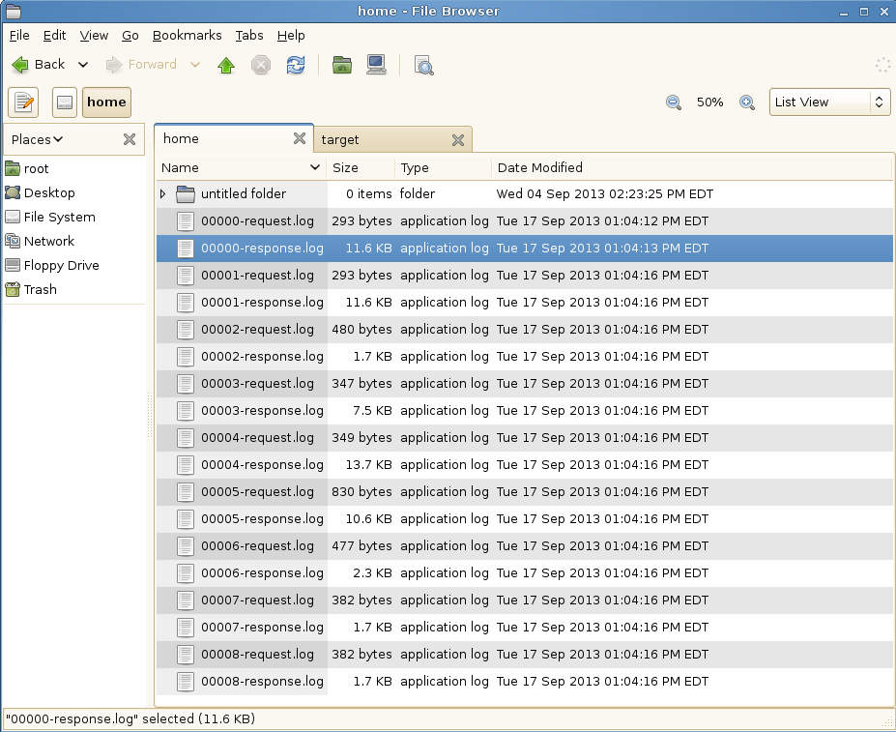
Next we will open up a couple of these and see what a typical browser trace looks like.

Examine the HTTP trace output
We are going to look as one of these requests so you can see what a typical trace looks like. Request 002 is a request to get the root folder object shown here:

GET /server/browser/test/root?objectId=%40root%40&cmisselector=object&includeAllowableActions=true&includeRelationships=none&renditionFilter=cmis%3Anone&includePolicyIds=false&includeACL=false&succinct=true HTTP/1.1
User-agent: Apache Chemistry OpenCMIS/1.0.0-SNAPSHOT
Authorization: Basic dGVzdDp0ZXN0
Accept-encoding: gzip,deflate
Cache-control: no-cache
Pragma: no-cache
Host: localhost:8080
Accept: text/html, image/gif, image/jpeg, *; q=.2, */*; q=.2
Connection: keep-alive

The response contains all of the properties for the folder formatted as JSON since we are using the browser binding. Here is the full text of the response:

HTTP/1.1 200
Content-Type: application/json;charset=UTF-8
Server: Apache-Chemistry-OpenCMIS/1.0.0-SNAPSHOT
Cache-Control: private, max-age=0

{
"succinctProperties":{
"cmis:objectId":"@root@",
"cmis:name":"",
"cmis:createdBy":"<unknown>",
"cmis:lastModifiedBy":"<unknown>",
"cmis:creationDate":1379287941000,
"cmis:lastModificationDate":1379287941000,
"cmis:changeToken":null,
"cmis:description":null,
"cmis:secondaryObjectTypeIds":null,
"cmis:baseTypeId":"cmis:folder",
"cmis:objectTypeId":"cmis:folder",
"cmis:path":"\/",
"cmis:parentId":null,
"cmis:allowedChildObjectTypeIds":null
},
"allowableActions":{
"canDeleteObject":false,
"canUpdateProperties":true,
"canGetFolderTree":true,
"canGetProperties":true,
"canGetObjectRelationships":false,
"canGetObjectParents":false,
"canGetFolderParent":false,
"canGetDescendants":true,
"canMoveObject":false,
"canDeleteContentStream":false,
"canCheckOut":false,
"canCancelCheckOut":false,
"canCheckIn":false,
"canSetContentStream":false,
"canGetAllVersions":false,
"canAddObjectToFolder":false,
"canRemoveObjectFromFolder":false,
"canGetContentStream":false,
"canApplyPolicy":false,
"canGetAppliedPolicies":false,
"canRemovePolicy":false,
"canGetChildren":true,
"canCreateDocument":true,
"canCreateFolder":true,
"canCreateRelationship":false,
"canCreateItem":false,
"canDeleteTree":true,
"canGetRenditions":false,
"canGetACL":true,
"canApplyACL":false
}
}

As you can imagine. Having this level of tracing detail can prove invaluable when you are doing interoperability tests with 3rd party CMIS clients.

Exercise 6: Testing your CMIS server

The objective of a CMIS server is to be able to serve any CMIS client. Compliance with the CMIS specification is key. To make this compliance easier, OpenCMIS provides a test utility called the Test Compatibility Kit (TCK), which makes a few hundred calls to the repository and checks if the repository reacts as defined in the CMIS specification. It covers most areas of the specification and is an essential testing tool. It cannot replace repository specific tests, though.

In this exercise we run the OpenCMIS TCK against the final version of the FileBridge Repository. The TCK is a library and can be triggered in many different ways. There is, for example, an Ant task to run the TCK and all TCK test are also JUnit tests. You can build your own TCK runner or just use the CMIS Workbench. In this exercise we do the latter.

Open the CMIS Workbench and connect to the FileBridge server. When you press the TCK button in the Workbench toolbar, a dialog should open that lets you pick the tests you want to run (shown in the illustration below)

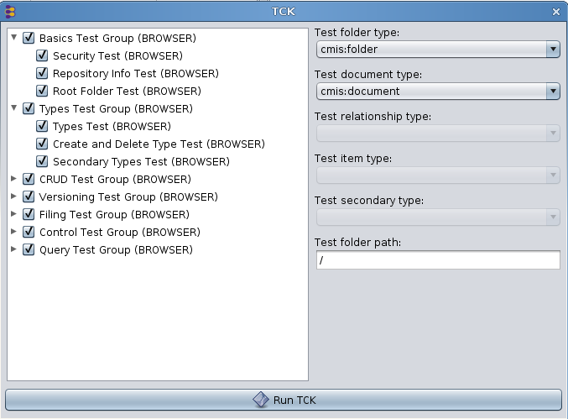

By default all tests are enabled.

Now run the TCK and wait for the results.

When the TCK run is done, a new window opens with the results. If you need more details, open the HTML report (at the bottom of the window). It contains more information and links to the test code. The illustration below shows the test report output dialog:

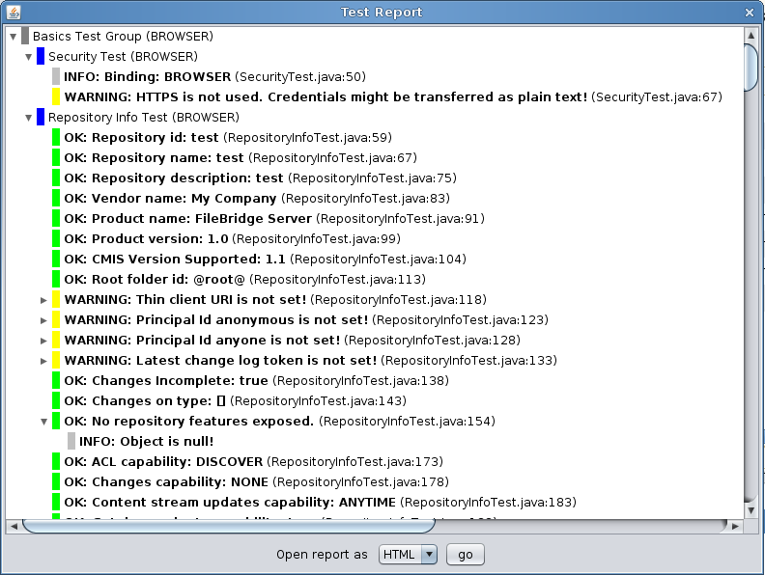

A TCK report can contain six different message types.

- INFO: Additional information about the test result.
- SKIPPED: The repository doesn’t support the feature and the test was skipped.
- OK: The test was successful.
- WARNING: The test was somewhat successful. The repository didn’t violate the specification, but there may be interoperability issues. You should analyze the cause of this warning and decide if you can ignore it.
- FAILURE: The TCK noticed a specification violation. There is something to fix.
- UNEXPECTED EXCEPTION: The TCK received an unexpected exception. There is probably a bug in the repository implementation.

Go through the report and check all warnings and failures. Why do you think the FileBridge server has failures?

Exercise 7: Supporting multiple repositories for your service
For this last exercise we will go back to the solution project we initially setup if you don't have your lab version running yet since we will need a working version of our FileBridge server. First we are going to have a look at the code that reads and parses the
repository.properties file. Please navigate to the FileBridgeCmisServiceFactory class and then to the

private void readConfiguration(...)

method. Here take a moment to see how we are currently parsing the .properties file to get a list of the repositories that we will expose from our getRepositories implementation. Of course this is entirely arbitrary how we are doing this, the important thing to note here is that we are maintaining a list of the repositories and their IDs. Even though your native service may only have one repository that does not mean that you cannot synthesize additional ones. For example you would have one repository that serves up the documents, and one that serves up the same documents with with watermarks.
After you have absorbed what is going on here (in this case the code is self explanatory), open up the repository.properties file for editing.
Recall the location of this file is shown in the illustration for the “A Note about Running From Windows” section.
(also note that this example will be for Linux. If you are using Windows please modify the file paths to something with a local drive letter and path as we did earlier.

Add another section to your .properties file like the example below:

class=org.example.cmis.server.FileBridgeCmisServiceFactory

login.1 = test:test
login.2 = reader:reader

repository.test = /
repository.test.readwrite = test
repository.test.readonly = reader

repository.test2 = /home
repository.test2.readwrite = test
repository.test2.readonly = reader

then start your server and reconnect with Workbench. Once you have done a load repositories, you should see your new 'test2' repository as shown in the illustration below.

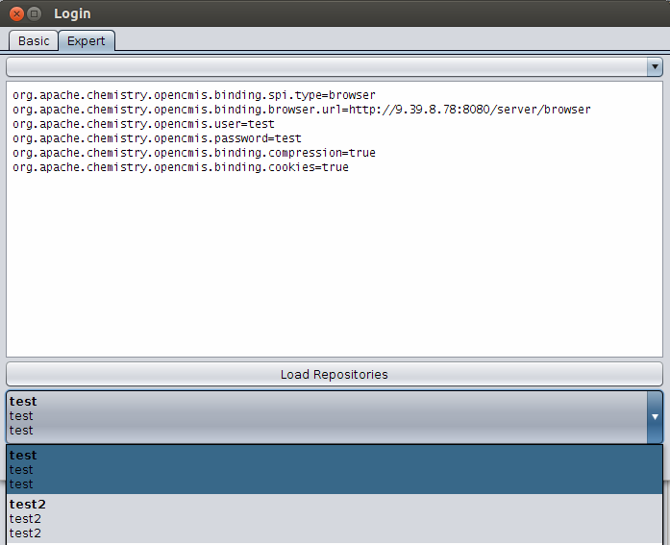

Another example would be to have the code dynamically discover all of the mounted filesystems (e.g. network drives) (for Windows use each drive letter) and expose each as its own repository. (left as an exercise for the student)

Miscellany for Developers

IBM Content Navigator's CMIS client - minimum requirements
Different CMIS clients have different requirements. For example some may only with with the AtomPub binding. While others may required support for Query.
To be fully functional with IBM Content Navigator's CMIS client, a CMIS Server must meet the following requirements:
- CMIS 1.0 compliant
- expose the optional capabilityQuery = metadataOnly (or greater)
  - This is used to more efficiently get document folder children separately from folder children for the different pane displays.
Other than the extra query capability there are no other 'optional' features needed. The
Manning CMIS book (see references section) chapter 14 covers the subject of building a
query parser which we will not be able to cover in this short tutorial.
Instead for this tutorial we have added a tiny bit of code to fileBridge so that is can handle two specific queries namely :

SELECT * from cmis:document WHERE in_folder('xx')
and
SELECT * from cmis:folder WHERE in_folder('xx')

With this tiny bit of query code added (see FileBridgeRepository.query()) fileBridge is
compatible with Navigator. See illustration below showing Navigator browsing our local
filesystem:

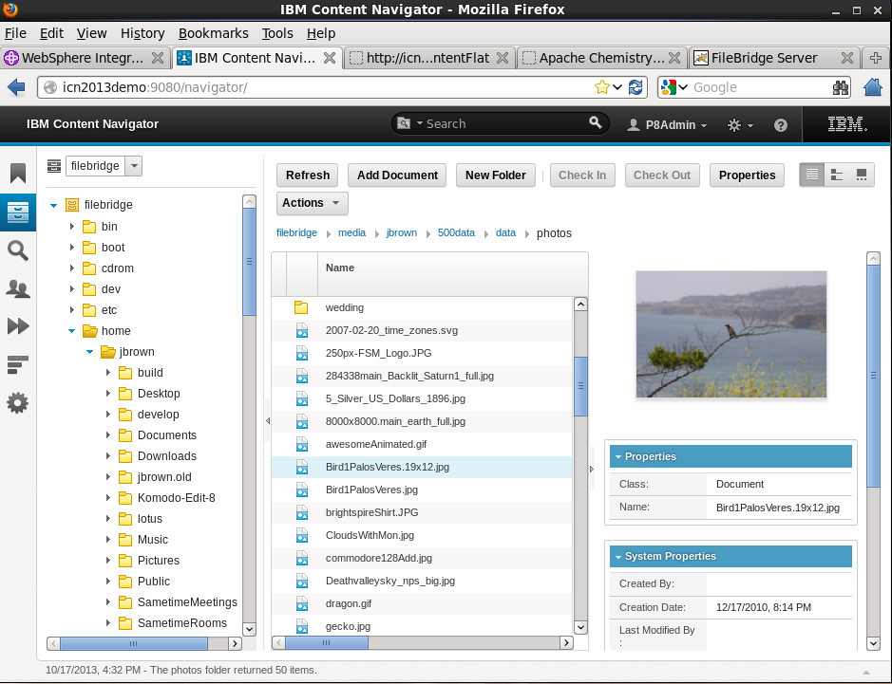
Illustration 7: IBM Content Navigator browsing our demo fileBridge repository.

Subversion clients for Windows
- (GUI) TortoiseSVN - http://sourceforge.net/projects/tortoisesvn/
- (command line) – These are listed in the Windows section toward the bottom of http://subversion.apache.org/packages.html

Auto start Chemistry Workbench connected to your server
If you would like your Workbench to start up every time connected to the same server with the same credentials. (As is often the case in developer environments)

Create a shell file to kick off Workbench along these lines (linux version):

#! /bin/sh
export CUSTOM_JAVA_OPTS="\
-Dcmis.workbench.binding=browser \
-Dcmis.workbench.url=http://localhost:8080/server/browser \
-Dcmis.workbench.user=test \
-Dcmis.workbench.password=test \
-Dcmis.workbench.compression=true \
-Dcmis.workbench.cookies=true"

# Now cd to your directory where you have Workbench
# then run the stock workbench.sh script.
./workbench.sh

Conclusion
This concludes this document. In this tutorial you have become familiar with the following:
- Building OpenCMIS server and client library dependencies from the source.
- Setting up a typical OpenCMIS server build environment using Eclipse and Maven 3.
- Familiarity with the Chemistry Workbench CMIS client.
- Understanding key points necessary to build an OpenCMIS server with enough functionality to be browsed by Chemistry Workbench client.
- Understanding how to add additional library dependencies to your server as in the case for a logging framework.
- Understand how to hook up HTTP tracing for debugging and interoperability testing.

Resources
OASIS CMIS 1.1 Specification : http://docs.oasis-open.org/cmis/CMIS/v1.1/os/CMIS-v1.1-os.html
OASIS CMIS 1.1 Specification (PDF version) : http://docs.oasis-open.org/cmis/CMIS/v1.1/CMIS-v1.1.pdf
CMIS Cheat Sheet : http://cmis.alfresco.com/cmis-cheatsheet.pdf
CMIS and Apache Chemistry in Action (Manning) : http://www.manning.com/mueller/
OpenCMIS 0.10.0 JavaDoc : http://chemistry.apache.org/java/0.10.0/maven/apidocs/
Apache Maven : http://maven.apache.org/
Eclipse : http://eclipse.org/
Apache Chemistry : http://chemistry.apache.org/

